Build A Stock Market App with Node and JavaScript

Prepare utk di install lebih dulu kalua belum ada:  
Git BASH : https://github.com/git-for-windows/git/releases/download/v2.42.0.windows.1/Git-2.42.0-64-bit.exe

NodeJS : <https://nodejs.org/en> (pilih yg LTS)

Wamp : <https://sourceforge.net/projects/wampserver/>

Buka Git Bash Console

* Start New App with NPM Init

* Install express js and set port

Create file index.js

* Build our first webpage

Buat folder baru dg nama public

Buat file index.html dlm folder public

Kemudian ambil template html code seperti capture dibawah

Kembali ke file index.js, kemudian tambahkan baris code berikut, kemudian save

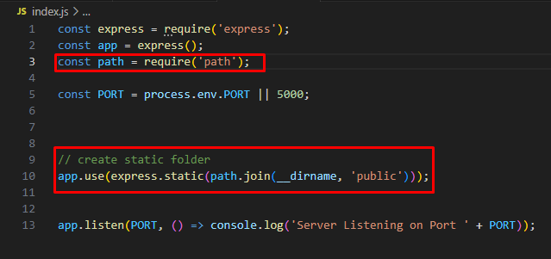

Ctr+C pada bash console, kemudian jalankan kembali node index.js

Dan refresh browser

Buat file about.htm dalam folder public, kemudian copy paste isi dari file index.html dan ubah sedikit

Check browser

* Set up Nodemon

Cek apakah berhasil running

Capture diasa berhasil running, lanjut step berikutnya

Modify file package.json

Jalankan node nya dengan command yg berbeda dg sebelumnya

* Install Handlebars

Ctrl+C supaya node yg jalan mati

Modify kembali file index.js

Buat folder views

Dlm folder views buat file dg nama home.handlebars, kemudian buat folder baru lagi dlm folder views dg nama layouts

Buat file dg nama main.handlebars di dlm folder layouts

* Handlebars page

Copy isi dari file index.html dan paste ke file main.handlebars dan edit

Edit file home.handlebars seperti berikut

Jalankan kembali servernya

Hasilnya di browser

Pass variables to handlebars

Modify file home.handlebars

Kemudian modify fle index.js, bisa dg 2 cara

Cara 1

Hasilnya

Cara 2

Hasilnya

Version control with Git

Generate ssh key untuk di pasang di github.com

Pastikan ada di direktori profile

Buat direktori .ssh

Masuk ke direktori .ssh

Buka file id_rsa.pub dan copy isinya

Masuk ke github.com untuk pasang key yg tadi di copy

Apabila init berhasil, muncul tulisan master

1. $ git config --global user.name "Your Name"
2. $ git config --global user.email "you@youraddress.com"
3. $ git config --global push.default matching
4. $ git config --global alias.co checkout
5. $ git init

Push code to github

Masuk ke akun github.com utk buat repository

git remote add origin https://github.com/firmansy85/build-a-stock-market-app.git

git branch -M master

git push -u origin master

git add .

git commit -am “initial commit”

git push (kalo gagal jlnin command dibawah)

git push -f --set-upstream origin master

Coba update salah 1 file contoh index.js ditambahkan comment

